**Project Design Phase - II**

**Data Flow Diagram & User Stories**

|  |  |
| --- | --- |
| Date | 16 October 2022 |
| Team ID | PNT2022TMID06547 |
| Project Name | Real -Time Communication System Powered by AI for Specially abled |
| Maximum Mark | 4 Marks |

**Dataflow diagram:**

A Data Flow Diagram (DFD) is a traditional visual representation of the information flows within a system. A neat and clear DFD can depict the right amount of the system requirement graphically. It shows how data enters and leaves the system, what changes the information, and where data is stored.

**Dataflow diagram:**

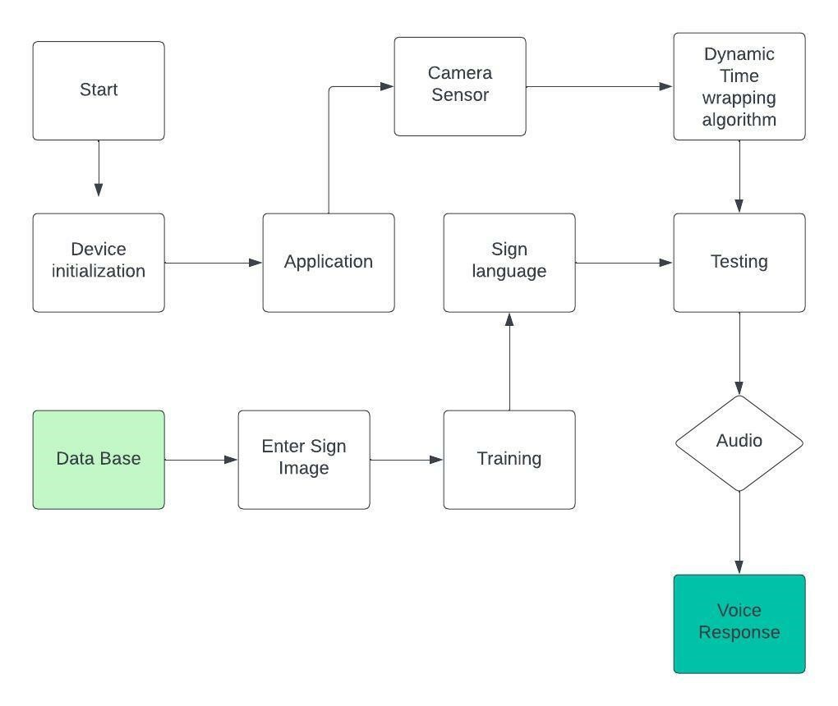

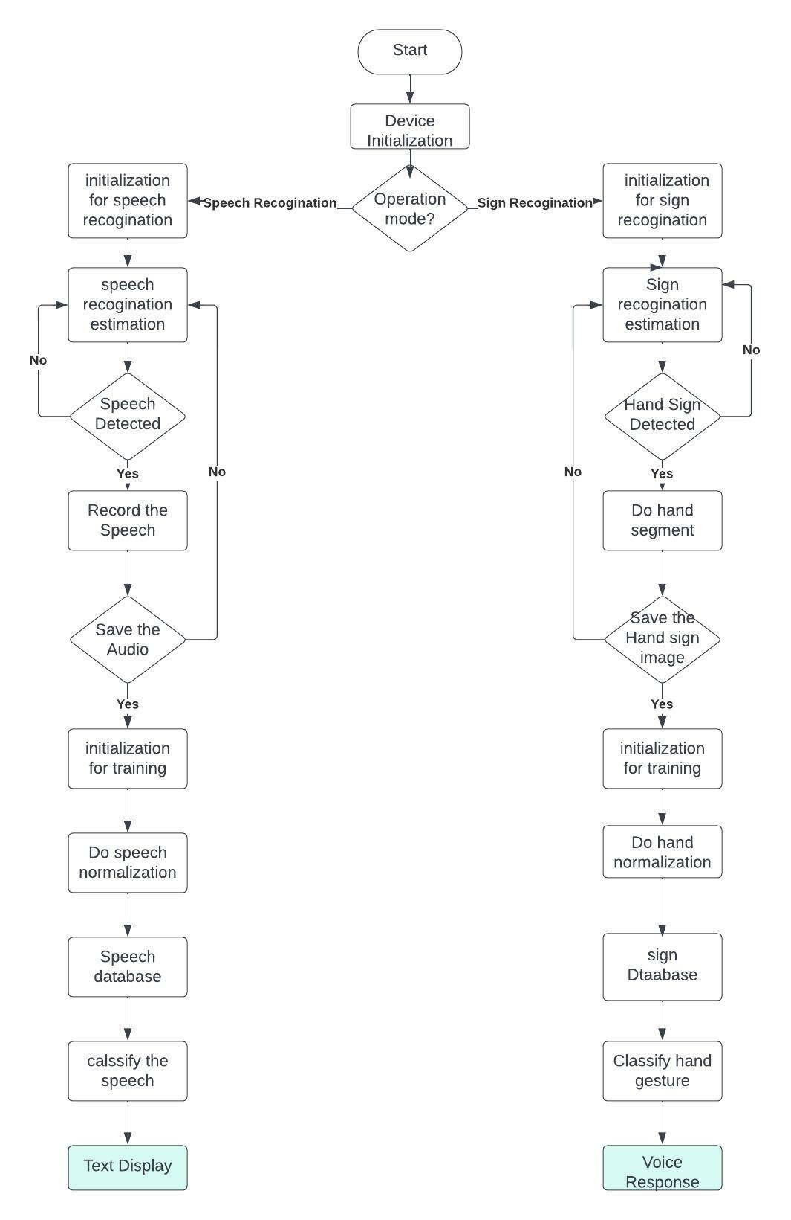

**User Stories**

**Use the below template to list all the user stories for the product.**

|  |  |  |  |  |  |  |
| --- | --- | --- | --- | --- | --- | --- |
| **User Type** | **Functional**  **Requirement**  **(Epic)** | **User**  **Story**  **Number** | **User Story / Task** | **Acceptance criteria** | **Priority** | **Release** |
| ***Customer***  *(Desktop user)* | Registration | USN-1 | As a user, I can register for the application by entering my email, password, and confirming my password. | I can access my account / dashboard | High | Sprint-1 |
|  | **Login** | USN-2 | As a user, I will receive confirmation email once I have registered for the application | I can receive confirmation email & click confirm | High | Sprint-1 |
|  | **Dashboard** | USN-3 | As a user, I can select options in dashboard. | I can select options in dashboard. |  |  |
| ***Customer*** *(Desktop user)* | **Main page** | USN-4 | As a User, **I can enter the web**  **page once clicked, which provides be the Guidelines** to use the app | I can **enter the web page** once clicked. | Medium | Sprint-1 |
| *Customer*  *(Desktop user)* | **Guidelines** | USN-5 | As a User, **I can give a read through the guidelines to understand the functioning of the app.** | I can **give a read through the guidelines.** | Medium | Sprint-1 |
| ***Customer***  *(Desktop user)* | **Convert Sign** | USN-6 | As a User, **I can click the button Convert sign**, which directs me towards the Main screen | I can **click the button Convert sign and it direct me to main screen.** | Medium | Sprint-2 |
| ***Customer***  *(Desktop user)* | **Camera (Hand movement detection)** | USN-7 | As a User, **I can show my hand sign towards the camera which converts them into text manner.** | **I can show my hand sign** towards the camera accurately. | High | Sprint-2 |
| ***Customer***  *(Desktop user)* | **Voice mode** | USN-8 | Once the text is obtained, as a User **I can click on the voice mode which provides the text in the form of speech.** | **I can click on the voice mode** which provides the text in the form of speech. | High | Sprint-3 |
| ***Customer Care***  ***Executive*** | **Provide the necessary**  **functionalities**  **required to use the app.** | USN-9 | As an Executive, I can **provide the Specifications of Camera required, and other factors** that are required for smooth functioning of the app. | **I can provide the Specifications** of camera required, and other factors | Low | Sprint-1 |
| ***Customer Care***  ***Executive*** | **Check the performance of the app** | USN-10 | As an Executive, I can **check the usage and queries obtained from the end users**. | I can **check the usage and queries** obtained from the end users. | Medium | Sprint-1 |
| ***Administrator*** | **Receive queries based on usage** | USN-11 | As an Admin, I can **take the queries from the customer care and perform the testing phase again, loading the other signs in**  **the dataset**, in order to make the customers to use the app effectively. | I can **take the queries from the customer care and perform necessary phases again.** | High | Sprint-3 |